**Week 6- React**

1. ReactJS-HOL

App.js

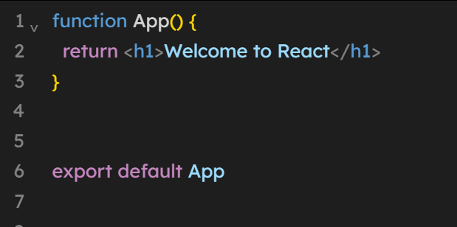

Output:-



2. ReactJS-HOL

**App.js**

import React from 'react';

import Home from './Component/Home.js';

import About from './Component/About.js';

import Contact from './Component/Contact.js';

function App() {

return (

<div className="container">

<Home />

<About />

<Contact />

</div>

);

}

export default App;

**Home.js**

import React, { Component } from 'react';

class Home extends Component {

render() {

return (

<div>

<h3>Welcome to the Home Page of Student Management Portal</h3>

</div>

);

}

}

export default Home;

**About.js**

import React, { Component } from 'react';

class About extends Component {

render() {

return (

<div>

<h3>Welcome to the About page of the Student Management Portal</h3>

</div>

);

}

}

export default About;

**Contact.js**

import React, { Component } from 'react';

class Contact extends Component {

render() {

return (

<div>

<h3>Welcome to the Contact page of the Student Management Portal</h3>

</div>

);

}

}

export default Contact;

**Output:**

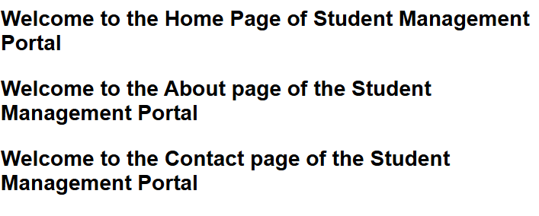

3. ReactJS-HOL

**App.js**

import React from 'react';

import { CalculateScore } from './Components/CalculateScore';

function App() {

return (

<div>

<CalculateScore

Name="Hima"

School="XYZ School"

total={480}

goal={500}

/>

</div>

);

}

export default App;

**CalculateScore.js**

import React from 'react';

import '../styles.css';

const percentToDecimal = (decimal) => {

return (decimal.toFixed(2) + '%');

};

const calcScore = (total, goal) => {

return percentToDecimal(total*100 / goal);

};

export const CalculateScore = ({ Name, School, total, goal }) => (

<div className="formatstyle">

<h1><font color="Brown">Student Details:</font></h1>

<div className="Name">

<b><span>Name: </span></b>

<span>{Name}</span>

</div>

<div className="School">

<b><span>School: </span></b>

<span>{School}</span>

</div>

<div className="Total">

<b><span>Total: </span></b>

<span>{total}</span> Marks

</div>

<div className="Score">

<b>Score:</b>

<span> {calcScore(total, goal)}</span>

</div>

</div>

);

**Styles.css**

.Name {

font-weight: 300;

color: blue;

}

.School {

color: crimson;

}

.Total {

color: darkmagenta;

}

.formatstyle {

text-align: center;

font-size: large;

}

.Score {

color: forestgreen;

}

Output:

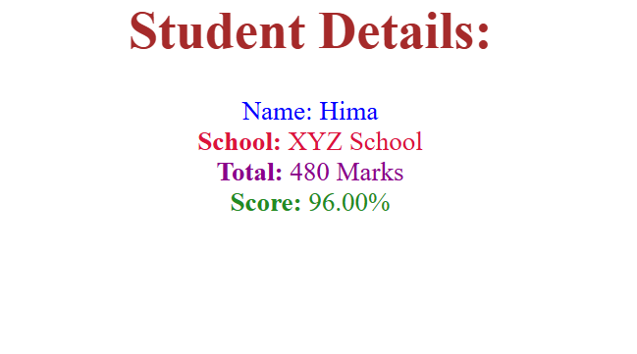

4. ReactJS-HOL

**Post.js (Model Class)**

class Post {

constructor(id, title, body) {

this.id = id;

this.title = title;

this.body = body;

}

}

export default Post;

**Posts.js (Component)**

import React from 'react';

import Post from './Post';

class Posts extends React.Component {

constructor(props) {

super(props);

this.state = {

posts: [],

hasError: false,

};

}

loadPosts() {

fetch('https://jsonplaceholder.typicode.com/posts')

.then(response => response.json())

.then(data => {

const postObjects = data.map(p => new Post(p.id, p.title, p.body));

this.setState({ posts: postObjects });

})

.catch(error => {

console.error("Error fetching posts:", error);

this.setState({ hasError: true });

});

}

componentDidMount() {

this.loadPosts();

}

componentDidCatch(error, info) {

alert("An error occurred: " + error);

}

render() {

return (

<div>

<h1>Blog Posts</h1>

{this.state.posts.map(post => (

<div key={post.id}>

<h2>{post.title}</h2>

<p>{post.body}</p>

</div>

))}

</div>

);

}

}

export default Posts;

**App.js**

import React from 'react';

import Posts from './Posts';

function App() {

return (

<div className="App">

<Posts />

</div>

);

}

export default App;

**Output:**

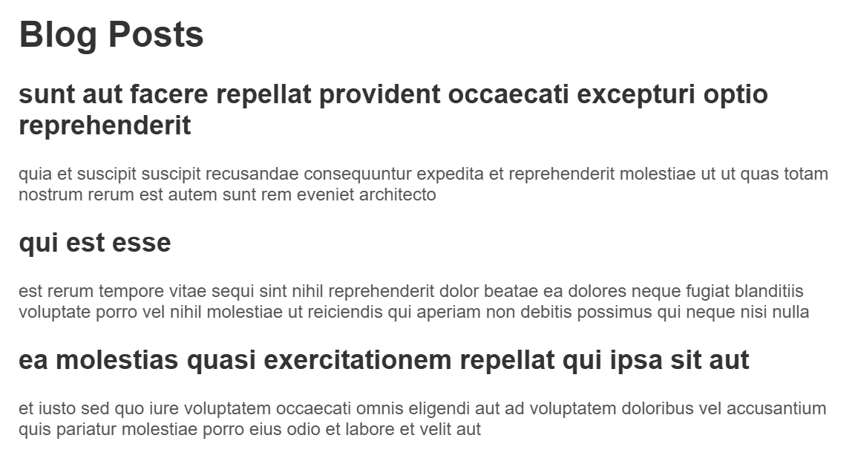

5. ReactJS-HOL

**CohortDetails.module.css**

.box {

width: 300px;

display: inline-block;

margin: 10px;

padding: 10px 20px;

border: 1px solid black;

border-radius: 10px;

}

dt {

font-weight: 500;

}

**CohortDetails.js**

import React from 'react';

import styles from './CohortDetails.module.css';

const CohortDetails = ({ cohort }) => {

const { name, startedOn, status, coach, trainer } = cohort;

const isOngoing = status.toLowerCase() === 'ongoing';

const headingStyle = { color: isOngoing ? 'green' : 'blue' };

return (

<div className={styles.box}>

<h3 style={headingStyle}>{name}</h3>

<dl>

<dt>Started On</dt>

<dd>{startedOn}</dd>

<dt>Current Status</dt>

<dd>{status}</dd>

<dt>Coach</dt>

<dd>{coach}</dd>

<dt>Trainer</dt>

<dd>{trainer}</dd>

</dl>

</div>

);

};

export default CohortDetails;

**CohortDashboard.jsx**

import React from 'react';

import CohortDetails from './CohortDetails';

const cohorts = [

{

name: 'INTADMDF10 - .NET FSD',

startedOn: '22-Feb-2022',

status: 'Scheduled',

coach: 'Aathma',

trainer: 'Jojo Jose',

},

{

name: 'ADM21JF014 - Java FSD',

startedOn: '10-Sep-2021',

status: 'Ongoing',

coach: 'Apoorv',

trainer: 'Elisa Smith',

},

{

name: 'CDBJF21025 - Java FSD',

startedOn: '24-Dec-2021',

status: 'Ongoing',

coach: 'Aathma',

trainer: 'John Doe',

},

];

const CohortDashboard = () => {

return (

<div>

<h2>Cohorts Details</h2>

{cohorts.map((cohort, index) => (

<CohortDetails key={index} cohort={cohort} />

))}

</div>

);

};

export default CohortDashboard;

**App.jsx**

import React from 'react';

import CohortDashboard from './CohortDashboard';

function App() {

return (

<div className="App">

<CohortDashboard />

</div>

);

}

export default App;

**Output:**

